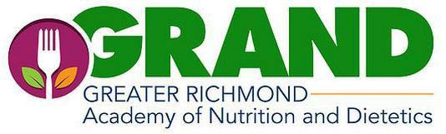

2020-2021 GRAND Membership Application
*You must be a CURRENT member of the national Academy of Nutrition & Dietetics to join GRAND. If your AND membership is not current or state affiliation/address needs to be updated, please update within the next 48 hours so your GRAND application processes correctly.
(Note: Students and interns are free but must fill out application annually)
Name:

Address:

Contact phone #:
AND #:

Email address:

Do you live in another district, but are declaring GRAND as district of membership this year? ___________
Student or Intern (check one). Educational affiliation name
Please indicate your interest in the following with Yes/No:
  - Being listed on the Consulting Dietitians/Private Practice list on the GRAND website _________
Specialty areas:
  - Being included on GRAND Speaker list when GRAND receives request for a speaker
Specialty areas:
  - Being included on GRAND Mentor/Career Guidance List to support students/interns _____
  - Helping with future meetings and events _________
  - Becoming a future Board Member ________
  - Being considered for scholarships/awards this year through GRAND or VAND? ________
If YES, will you be 35 years of age or younger and a registered dietitian by May 1, 2021? ________
How many years have you been practicing as an RD or a DTR? _______

Please send your membership payment one of the following ways:
- Paypal at GRANDRVA.org - $26.50
- Check for $25.00 made out to GRAND with Registration 2020-2021 in memo.
Checks may be mailed to: GRAND c/o Jen Rabung 9331 Crestfield Drive Mechanicsville, VA 23116

Thank you for supporting your local organization of dietitians!

Any questions, please contact Sylvia Fetty, Membership Chair @ sylvia.fetty@vcuhealth.org.

